***PROIECT DATAWAREHOUSE***

~ Modul implementare baza de date ~

1. Crearea bazei de date OLTP și a utilizatorilor

--Baza noastra de date va avea 3 tipuri de utilizatori in aplicatie

-- utilizatorul manager care va introduce schema si cu toate datele din aplicatie.

-- acesta va avea acces la toate datele din schema oltp prin SELECT,UPDATE,DELETE,INSERT

-- Managerul are posibilitatea de a introduce rezervari,modifica utilizatori, update pe rezervari.

-- Practic are acces sa faca tot ce vrea pe schema

-- acesta va avea acces si in olap pentru a vizualiza rapoartele scoase dar

--si de a modifica datele din tabele dupa propriul interes.

show con_name;

alter session set container= orclpdb;

show con_name;

ALTER PLUGGABLE DATABASE orclpdb open;

CREATE USER dw_manager IDENTIFIED BY mng_pass;

GRANT CREATE SESSION TO dw_manager;

GRANT CREATE ANY TABLE TO dw_manager;

GRANT CREATE ANY INDEX TO dw_manager;

GRANT CREATE VIEW TO dw_manager;

GRANT CREATE TRIGGER TO dw_manager;

GRANT SELECT ANY TABLE TO dw_manager;

GRANT DELETE ANY TABLE TO dw_manager;

GRANT UPDATE ANY TABLE TO dw_manager;

GRANT ALTER ANY TABLE TO dw_manager;

GRANT UNLIMITED TABLESPACE TO dw_manager;

--Pentru a vizualiza privilegiile adaugate putem folosi aceasta cerere asupra utlizatorului creat.

SELECT *

FROM session_privs;

-- intro schema si datele furnizate pentru schema

--SCHEMA CU TABELE TREBUIE RULATE IN dw_manager

--script creare schema oltp.txt

--DATELE DIN TABELE TREBUIE INTRODUSE IN dw_manager

--script inserare date oltp.txt

-- urmatorul tip va fi de tip admin care va avea posibilitatea de UPDATE peste toate tabele din schema OLTP

-- fara a avea posibilitatea de a sterge orice tip de inregistrare deoarece si inregistrarile neconforme pot reprezenta

-- un interes pentru manager.

CREATE USER dw_admin IDENTIFIED BY admin_pass;

GRANT CREATE SESSION TO dw_admin;

GRANT SELECT ANY TABLE TO dw_admin;

GRANT DELETE ANY TABLE TO dw_admin;

GRANT UPDATE ANY TABLE TO dw_admin;

GRANT ALTER ANY TABLE TO dw_admin;

--daca dorim sa oferim doar anumite privilegi mai restrictive asupra anumitor tabele putem folosi comanda urmatoare

--GRANT UPDATE ON dw_manager.rezervare TO dw_admin;

--sau daca dorim sa nu mai folosim anumite privilegii precum cel de mai putem folosi comanda

--REVOKE DELETE ON dw_manager.rezervare FROM dw_admin;

--pentru a accesa un tabel trebuie sa folosim dw_manager.nume_tabel deoarece altfel nu merge

-- iar ultimul tip de utilizator este cel cel de utilizator care are

-- posibilitatea sa vizualizeze hotelurile si sa introduce date in rezervari.

-- acesta nu avea acces la baza de date.

--ca si SYS putem rula urmatoarea cerere pentru a vizualiza care sunt care sunt privilegiile oferite

SELECT substr(grantee,1,20) grantee, owner,substr(table_name,1,15) table_name, grantor, privilege

FROM DBA_TAB_PRIVS

WHERE grantee like 'DW_%';

--cu aceasta comanda putem vedea doar privilegiile mai restrictive.

SET FEEDBACK 1

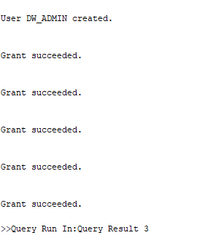

SET NUMWIDTH 10

SET LINESIZE 80

SET TRIMSPOOL ON

SET TAB OFF

SET PAGESIZE 100

SET ECHO OFF

REM ********************************************************************

REM Create the UTILIZATOR table to hold users information for application

Prompt ****** Creating UTILIZATOR table ....

CREATE TABLE utilizator

( id_utilizator NUMBER GENERATED ALWAYS as IDENTITY(START WITH 1 INCREMENT BY 1),

nume_utilizator VARCHAR(30) CONSTRAINT nume_utilizator_nn NOT NULL,

hash_parola VARCHAR(25) CONSTRAINT hash_parola_utilizator_nn NOT NULL,

nume_complet VARCHAR(30) CONSTRAINT nume_complet_utilizator_nn NOT NULL,

telefon VARCHAR(15) CONSTRAINT telefon_utilizator_nn NOT NULL,

email VARCHAR(50) CONSTRAINT email_utilizator_nn NOT NULL,

data_nasterii DATE CONSTRAINT data_nasterii_utilizator_nn NOT NULL,

gen VARCHAR(20) DEFAULT NULL,

stare_civila VARCHAR(20) DEFAULT NULL);

CREATE UNIQUE INDEX id_utilizator_index

ON utilizator (id_utilizator);

ALTER TABLE utilizator

ADD ( CONSTRAINT id_nume_utilizator_pk PRIMARY KEY (id_utilizator)) ;

CREATE UNIQUE INDEX id_utilizator_index

ON utilizator (id_utilizator);

ALTER TABLE utilizator

ADD ( CONSTRAINT id_nume_utilizator_pk PRIMARY KEY (id_utilizator)) ;

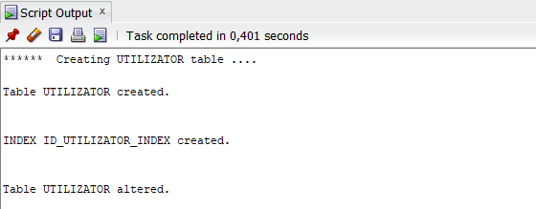

REM ********************************************************************

REM Create the REZERVARE table to hold information for reservation of users

Prompt ****** Creating REZERVARE table ....

CREATE TABLE rezervare

( id_rezervare NUMBER GENERATED ALWAYS as IDENTITY(START WITH 1 INCREMENT BY 1),

id_client NUMBER CONSTRAINT id_client_utilizator_nn NOT NULL,

data_inceput DATE CONSTRAINT data_inceput_rezervare_nn NOT NULL,

data_sfarsit DATE CONSTRAINT data_sfarsit_rezervare_nn NOT NULL,

data_efectuarii DATE);

CREATE UNIQUE INDEX id_rezervare_index

ON rezervare (id_rezervare);

ALTER TABLE rezervare

ADD ( CONSTRAINT id_rezervare_pk PRIMARY KEY (id_rezervare)) ;

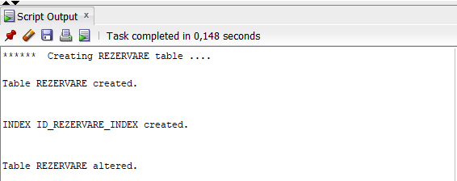

REM ********************************************************************

REM Create the REZERVARE CAMERA table to hold information about rooms of users

Prompt ****** Creating REZERVARE CAMERA table ....

CREATE TABLE rezervare_camera

( id_rezervare NUMBER CONSTRAINT id_rezervare_atribuie_nn NOT NULL,

id_camera NUMBER CONSTRAINT id_camera_atribuie_nn NOT NULL);

CREATE UNIQUE INDEX id_rezervare_camera_index

ON rezervare_camera (id_rezervare,id_camera);

ALTER TABLE rezervare_camera

ADD ( CONSTRAINT id_rezervare_camera__pk PRIMARY KEY (id_rezervare,id_camera));

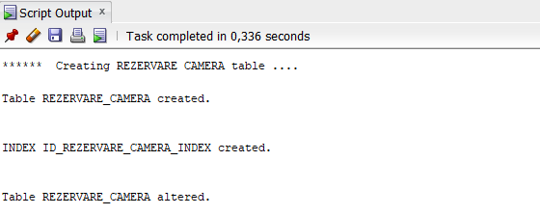

REM ********************************************************************

REM Create the CAMERA table to hold informations about rooms

Prompt ****** Creating CAMERA table ....

CREATE TABLE camera

( id_camera NUMBER GENERATED ALWAYS as IDENTITY(START WITH 1 INCREMENT BY 1),

id_hotel NUMBER CONSTRAINT id_hotel_camera_nn NOT NULL,

nr_camera NUMBER,

nr_etaj NUMBER,

nr_paturi_duble NUMBER CONSTRAINT nr_paturi_duble_camera_nn NOT NULL,

nr_paturi_simple NUMBER CONSTRAINT nr_paturi_simple_camera_nn NOT NULL,

are_terasa NUMBER(1) CONSTRAINT are_terasa_camera_nn NOT NULL,

are_televizor NUMBER(1) CONSTRAINT are_televizor_camera_nn NOT NULL,

pret_per_noapte NUMBER CONSTRAINT pret_per_noapte_camera_nn NOT NULL);

CREATE UNIQUE INDEX id_camera_index

ON camera (id_camera);

ALTER TABLE camera

ADD ( CONSTRAINT id_camera_camera_pk PRIMARY KEY (id_camera)) ;

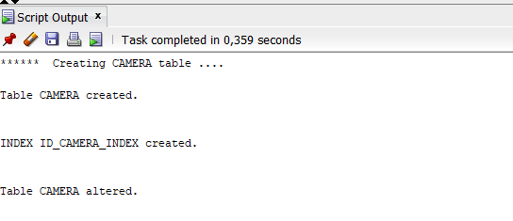

REM ********************************************************************

REM Create the HOTEL table to hold information of hotels

Prompt ****** Creating HOTEL table ....

CREATE TABLE hotel

( id_hotel NUMBER GENERATED ALWAYS as IDENTITY(START WITH 1 INCREMENT BY 1),

nume VARCHAR2(50) CONSTRAINT nume_hotel_hotel_nn NOT NULL,

nr_stele NUMBER CONSTRAINT nr_stele_nn NOT NULL,

id_zona NUMBER CONSTRAINT id_zona_hotel_nn NOT NULL,

are_mic_dejun_inclus NUMBER(1) CONSTRAINT are_mic_dejun_inclus_hotel_nn NOT NULL);

CREATE UNIQUE INDEX id_hotel_index

ON hotel (id_hotel);

ALTER TABLE hotel

ADD ( CONSTRAINT id_hotel_hotel_pk PRIMARY KEY (id_hotel)) ;

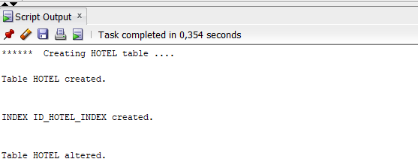

REM ********************************************************************

REM Create the ZONA table to hold informatation the zones where the hotels was build

Prompt ****** Creating ZONA table ....

CREATE TABLE zona

( id_zona NUMBER GENERATED ALWAYS as IDENTITY(START WITH 1 INCREMENT BY 1),

regiune VARCHAR2(50),

judet VARCHAR2(50) CONSTRAINT judet_zona_nn NOT NULL,

localitate VARCHAR2(50) CONSTRAINT localitate_zona_nn NOT NULL,

pozitie VARCHAR2(50) CONSTRAINT pozitie_zona_nn NOT NULL);

CREATE UNIQUE INDEX id_zona_zona_index

ON zona (id_zona);

ALTER TABLE zona

ADD ( CONSTRAINT id_zona_zona_pk PRIMARY KEY (id_zona)) ;

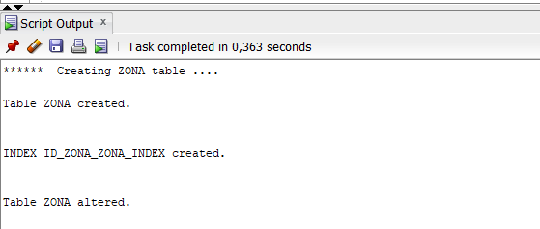

REM *********Introducerea de FK tabelului**** REZERVARE****************

Prompt ****** Creating FK Constraints on table REZERVARE ....

ALTER TABLE rezervare

add constraint fk_id_client_id_utilizator FOREIGN KEY(id_client) REFERENCES utilizator(id_utilizator);

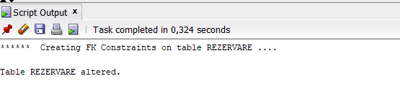

REM *********Introducerea de FK tabelului**** CAMERA****************

Prompt ****** Creating FK Constraints on table CAMERA ....

ALTER TABLE camera

add constraint fk_camera_hotel FOREIGN KEY(id_hotel) REFERENCES hotel(id_hotel);

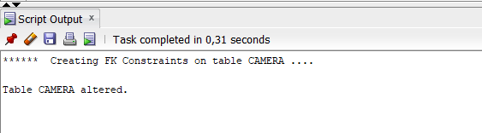

REM *********Introducerea de FK tabelului**** HOTEL****************

Prompt ****** Creating FK Constraints on table HOTEL ....

ALTER TABLE hotel

add constraint fk_hotel_zona FOREIGN KEY(id_zona) REFERENCES zona(id_zona);

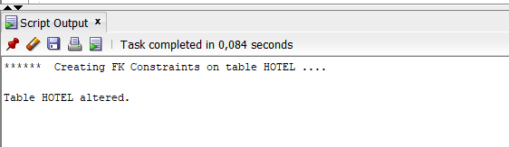

REM *********Introducerea de FK tabelului**** REZERVARE_CAMERA****************

Prompt ****** Creating FK Constraints on table REZERVARE_CAMERA ....

ALTER TABLE rezervare_camera

ADD CONSTRAINT fk_rezervare_camera_rezervare FOREIGN KEY(id_rezervare) REFERENCES rezervare(id_rezervare);

ALTER TABLE rezervare_camera

ADD CONSTRAINT fk_rezervare_camera_camera FOREIGN KEY (id_camera) REFERENCES camera(id_camera);

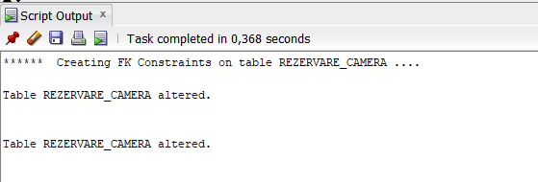

2. (0,25p) Generarea datelor și inserarea acestora în tabele.

---Inserarea datelor in tabelul ZONA---

INSERT INTO ZONA (JUDET, LOCALITATE, POZITIE) VALUES ('Mures','Targu Mures','centrala'); COMMIT;

INSERT INTO ZONA (JUDET, LOCALITATE, POZITIE) VALUES ('Brasov','Bran','centrala'); COMMIT;

INSERT INTO ZONA (JUDET, LOCALITATE, POZITIE) VALUES ('Brasov','Bran','periferica'); COMMIT;

INSERT INTO ZONA (JUDET, LOCALITATE, POZITIE) VALUES ('Bucuresti','Bucuresti','centrala'); COMMIT;

INSERT INTO ZONA (JUDET, LOCALITATE, POZITIE) VALUES ('Prahova','Sinaia','centrala'); COMMIT;

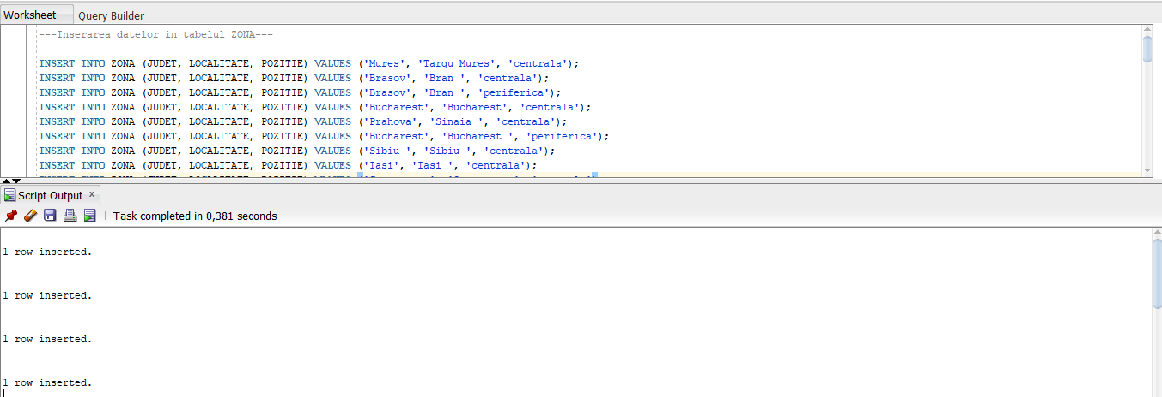

---Inserarea datelor in tabelul HOTEL(dependent de ZONA)---

INSERT INTO HOTEL (NUME, NR_STELE, ID_ZONA, ARE_MIC_DEJUN_INCLUS) VALUES ('Hotel Privo',4,1,0); COMMIT;

INSERT INTO HOTEL (NUME, NR_STELE, ID_ZONA, ARE_MIC_DEJUN_INCLUS) VALUES ('Conacul Bratescu', 4, 2, 1); COMMIT;

INSERT INTO HOTEL (NUME, NR_STELE, ID_ZONA, ARE_MIC_DEJUN_INCLUS) VALUES ('Transylvanian Inn', 3, 3, 1); COMMIT;

INSERT INTO HOTEL (NUME, NR_STELE, ID_ZONA, ARE_MIC_DEJUN_INCLUS) VALUES ('The Mansion Boutique Hotel', 4, 4, 1); COMMIT;

INSERT INTO HOTEL (NUME, NR_STELE, ID_ZONA, ARE_MIC_DEJUN_INCLUS) VALUES ('Ioana Hotel', 5, 5, 1); COMMIT;

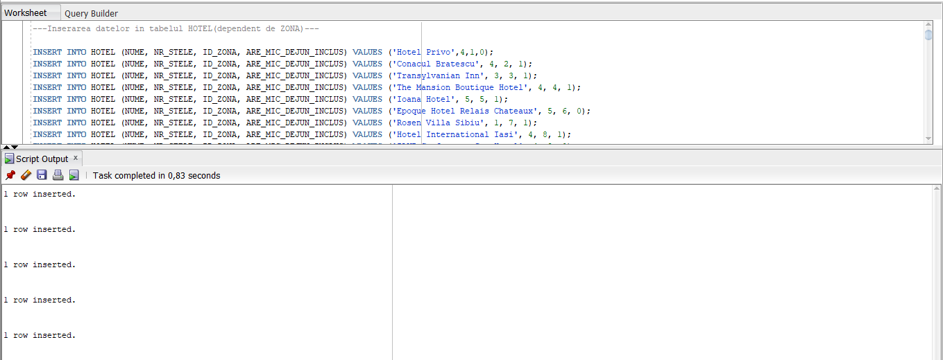

---Inserarea datelor in tabelul CAMERA(dependent de HOTEL)---

INSERT INTO CAMERA (ID_HOTEL, NR_CAMERA, NR_ETAJ, NR_PATURI_DUBLE, NR_PATURI_SIMPLE, ARE_TERASA, ARE_TELEVIZOR, PRET_PER_NOAPTE)

VALUES (76, 312, 3, 0, 3, 1, 0, 450); COMMIT;

INSERT INTO CAMERA (ID_HOTEL, NR_CAMERA, NR_ETAJ, NR_PATURI_DUBLE, NR_PATURI_SIMPLE, ARE_TERASA, ARE_TELEVIZOR, PRET_PER_NOAPTE)

VALUES (78, 107, 1, 0, 1, 1, 0, 100); COMMIT;

INSERT INTO CAMERA (ID_HOTEL, NR_CAMERA, NR_ETAJ, NR_PATURI_DUBLE, NR_PATURI_SIMPLE, ARE_TERASA, ARE_TELEVIZOR, PRET_PER_NOAPTE)

VALUES (44, 405, 4, 0, 2, 1, 0, 180); COMMIT;

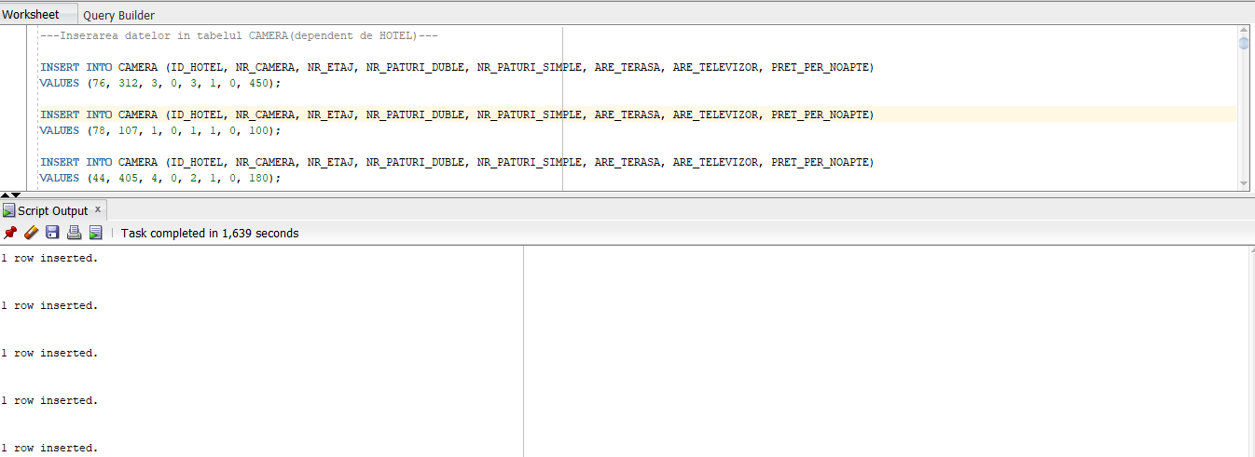

----------------------------------------------

---Inserarea datelor in tabelul UTILIZATOR---

INSERT INTO UTILIZATOR (NUME_UTILIZATOR, HASH_PAROLA, NUME_COMPLET, TELEFON, EMAIL, DATA_NASTERII, GEN, STARE_CIVILA)

VALUES ('bernard_noble', 'kr1O2h8', 'Bernard Noble', '+40 710 024 027', 'kstoltenberg@yahoo.com', to_date('13-Oct-1976', 'DD-MON-RR'), 'masculin', 'necasatorit '); COMMIT;

INSERT INTO UTILIZATOR (NUME_UTILIZATOR, HASH_PAROLA, NUME_COMPLET, TELEFON, EMAIL, DATA_NASTERII, GEN, STARE_CIVILA)

VALUES ('isis_saunders', 'PA3pnYV', 'Isis Saunders', '+40 713 721 929', 'orn.skye@huels.com', to_date('6-Apr-2001', 'DD-MON-RR'), 'feminin', 'casatorita'); COMMIT;

INSERT INTO UTILIZATOR (NUME_UTILIZATOR, HASH_PAROLA, NUME_COMPLET, TELEFON, EMAIL, DATA_NASTERII, GEN, STARE_CIVILA)

VALUES ('micaela_gillespie', 'G7fSXy8', 'Micaela Gillespie', '+40 713 037 240', 'stuart22@yahoo.com', to_date('19-Apr-1966', 'DD-MON-RR'), 'feminin', 'necasatorita'); COMMIT;

INSERT INTO UTILIZATOR (NUME_UTILIZATOR, HASH_PAROLA, NUME_COMPLET, TELEFON, EMAIL, DATA_NASTERII, GEN, STARE_CIVILA)

VALUES ('gilbert_mccarty', 'ek1Rwcq', 'Gilbert Mccarty', '+40 711 666 147', 'gskiles@altenwerth.com', to_date('31-Jul-1969', 'DD-MON-RR'), 'masculin', 'necasatorit '); COMMIT;

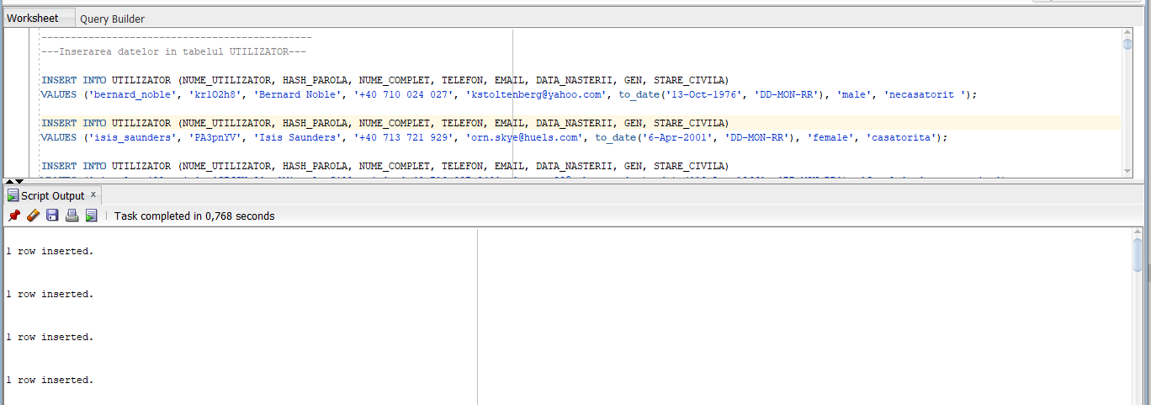

---Inserarea datelor in tabelul REZERVARE(dependent de UTILIZATOR)---

INSERT INTO REZERVARE (ID_CLIENT, DATA_INCEPUT, DATA_SFARSIT)

VALUES (89, to_date('2-Jul-2023', 'DD-MON-RR'), to_date('9-Jul-2023', 'DD-MON-RR')); COMMIT;

INSERT INTO REZERVARE (ID_CLIENT, DATA_INCEPUT, DATA_SFARSIT)

VALUES (49, to_date('4-Feb-2025', 'DD-MON-RR'), to_date('13-Feb-2025', 'DD-MON-RR')); COMMIT;

INSERT INTO REZERVARE (ID_CLIENT, DATA_INCEPUT, DATA_SFARSIT)

VALUES (4, to_date('24-Apr-2023', 'DD-MON-RR'), to_date('27-Apr-2023', 'DD-MON-RR')); COMMIT;

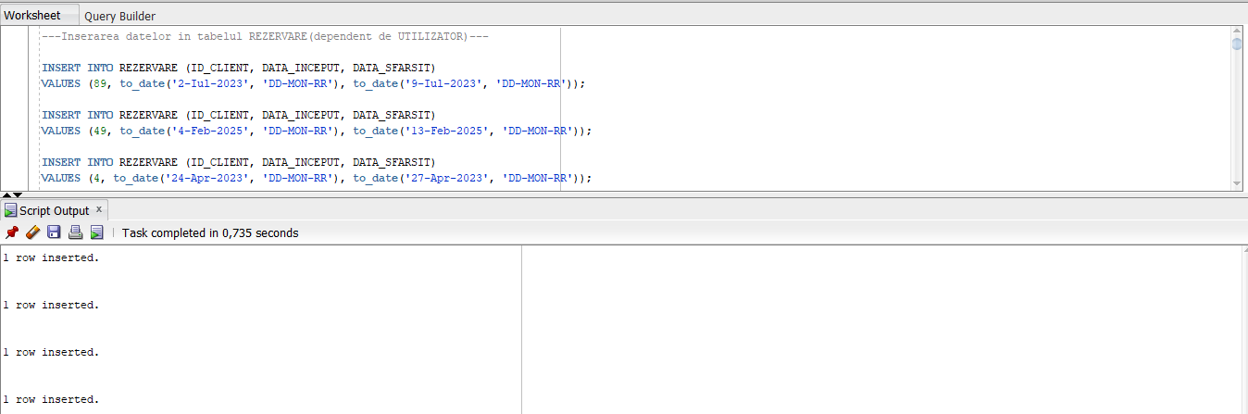

----------------------------------------------

---Inserarea datelor in tabelul REZERVARE_CAMERA---

INSERT INTO REZERVARE_CAMERA (ID_REZERVARE, ID_CAMERA)

VALUES (95, 167);

INSERT INTO REZERVARE_CAMERA (ID_REZERVARE, ID_CAMERA)

VALUES (93, 54);

INSERT INTO REZERVARE_CAMERA (ID_REZERVARE, ID_CAMERA)

VALUES (47, 140);

INSERT INTO REZERVARE_CAMERA (ID_REZERVARE, ID_CAMERA)

VALUES (93, 71);

INSERT INTO REZERVARE_CAMERA (ID_REZERVARE, ID_CAMERA)

VALUES (10, 154);

INSERT INTO REZERVARE_CAMERA (ID_REZERVARE, ID_CAMERA)

VALUES (4, 120);

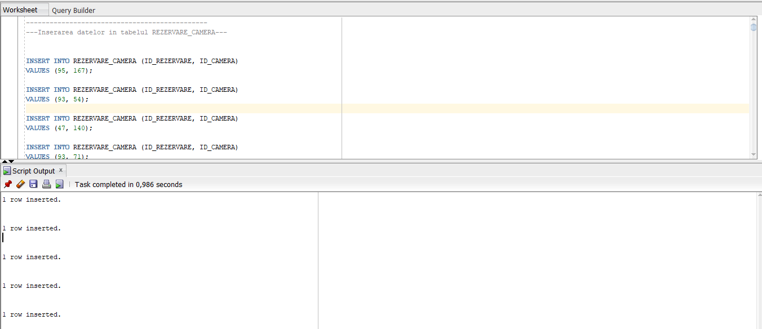

--GENEREAZA O DATA ALEATOARE A EFECTUARII PENTRU FIECARE REZERVARE

UPDATE rezervare SET data_efectuarii=TO_DATE(TRUNC(DBMS_RANDOM.VALUE(TO_CHAR(DATE'2022-01-01','J'),TO_CHAR(DATE'2022-12-31','J'))),'J'); COMMIT;

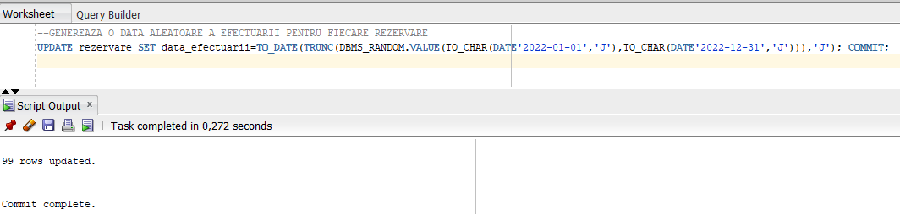

--SETEAZA REGIUNILE ASOCIATE JUDETELOR

UPDATE zona

SET regiune='Transilvania'

WHERE judet='Cluj' OR judet='Brasov' OR judet='Sibiu' OR judet='Mures'; COMMIT;

UPDATE zona

SET regiune='Maramures'

WHERE judet='Maramures' OR judet='Satu Mare'; COMMIT;

UPDATE zona

SET regiune='Muntenia'

WHERE judet='Prahova' OR judet='Ilfov' OR judet='Arges' OR judet='Buzau' OR judet='Bucuresti'; COMMIT;

UPDATE zona

SET regiune='Oltenia'

WHERE judet='Valcea'; COMMIT;

UPDATE zona

SET regiune='Dobrogea'

WHERE judet='Constanta'; COMMIT;

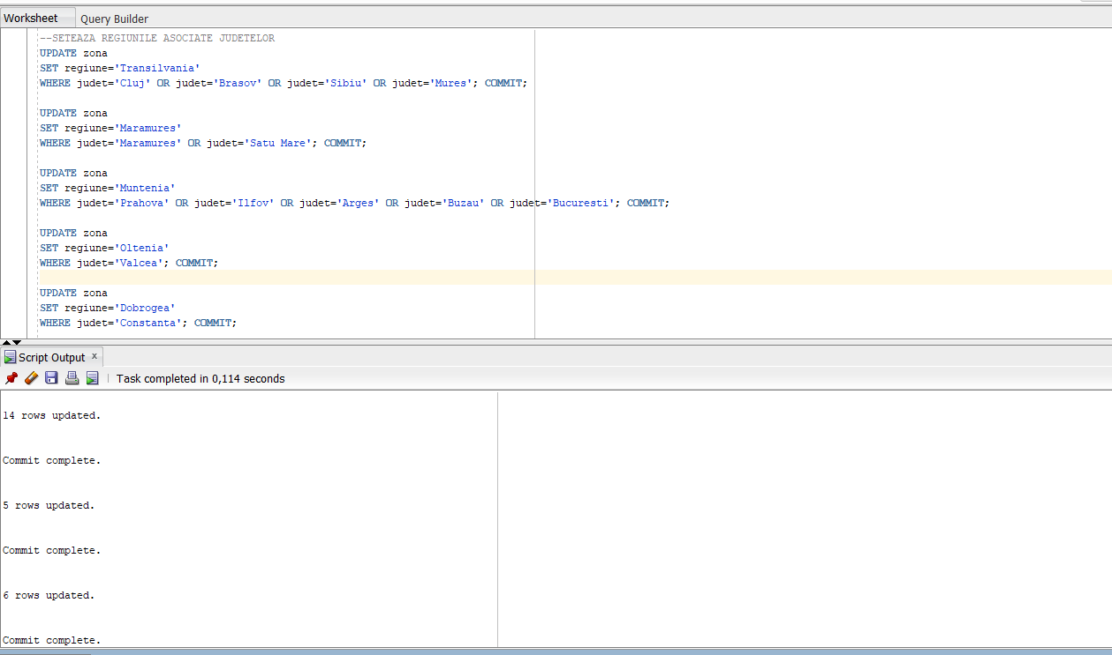

3. (0,5p) Crearea bazei de date depozit și a utilizatorilor

Schema bazei de date depozit a fost introdusă în conexiunea utilizatorului dw_manager. Acest utilizator a fost creat asemănător cu utlizatorul pentru baza de date OLTP.

CREATE TABLE perioada_rezervare_OLAP(

id_perioada NUMBER(8,0) GENERATED ALWAYS as IDENTITY(START WITH 1 INCREMENT BY 1),

zi_din_luna_inceput NUMBER(2,0) CONSTRAINT zi_din_luna_inceput_nn_OLAP NOT NULL RELY DISABLE NOVALIDATE,

luna_inceput CHAR(3) CONSTRAINT luna_inceput_nn_OLAP NOT NULL RELY DISABLE NOVALIDATE,

an_inceput NUMBER(4,0)CONSTRAINT an_inceput_nn_OLAP NOT NULL RELY DISABLE NOVALIDATE,

zi_din_saptamana_inceput CHAR(3) CONSTRAINT zi_din_saptamana_inceput_nn_OLAP NOT NULL RELY DISABLE NOVALIDATE,

zi_din_an_inceput NUMBER(3,0) CONSTRAINT zi_din_an_inceput_nn_OLAP NOT NULL RELY DISABLE NOVALIDATE,

zi_din_luna_sfarsit NUMBER(2,0) CONSTRAINT zi_din_luna_sfarsit_nn_OLAP NOT NULL RELY DISABLE NOVALIDATE,

luna_sfarsit CHAR(3) CONSTRAINT luna_sfarsit_nn_OLAP NOT NULL RELY DISABLE NOVALIDATE,

an_sfarsit NUMBER(4,0) CONSTRAINT an_sfarsit_nn_OLAP NOT NULL RELY DISABLE NOVALIDATE,

zi_din_saptamana_sfarsit CHAR(3) CONSTRAINT zi_din_saptamana_sfarsit_nn_OLAP NOT NULL RELY DISABLE NOVALIDATE,

zi_din_an_sfarsit NUMBER(3,0) CONSTRAINT zi_din_an_sfarsit_nn_OLAP NOT NULL RELY DISABLE NOVALIDATE,

durata_in_zile NUMBER(2,0) CONSTRAINT durata_in_zile_nn_OLAP NOT NULL RELY DISABLE NOVALIDATE,

PRIMARY KEY(id_perioada)

);

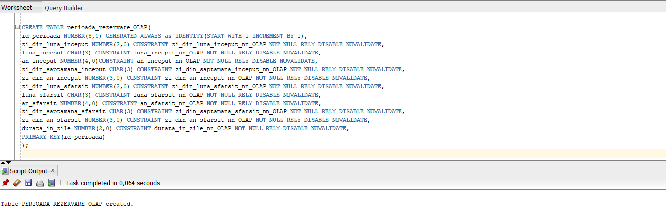

CREATE TABLE tip_camera_OLAP(

id_tip_camera NUMBER(8)GENERATED ALWAYS as IDENTITY(START WITH 1 INCREMENT BY 1),

nr_paturi_duble NUMBER(1) CONSTRAINT nr_paturi_duble_nn_OLAP NOT NULL RELY DISABLE NOVALIDATE,

nr_paturi_simple NUMBER(1)CONSTRAINT nr_paturi_simple_nn_OLAP NOT NULL RELY DISABLE NOVALIDATE,

are_terasa NUMBER(1)CONSTRAINT are_terasa_nn_OLAP NOT NULL RELY DISABLE NOVALIDATE,

are_televizor NUMBER(1) CONSTRAINT are_telezivor_nn_OLAP NOT NULL RELY DISABLE NOVALIDATE,

PRIMARY KEY (id_tip_camera)

);

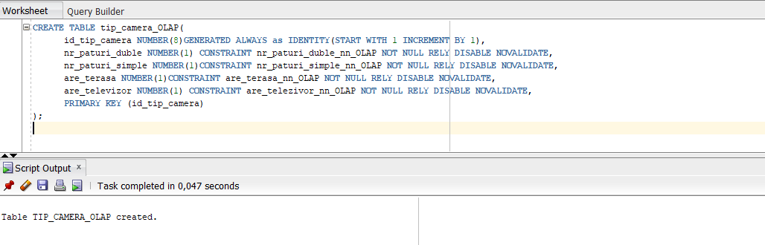

CREATE TABLE hotel_OLAP

(

id_hotel NUMBER(8),

nume VARCHAR2(50) CONSTRAINT nume_nn_OLAP NOT NULL RELY DISABLE NOVALIDATE,

nr_stele NUMBER(1) CONSTRAINT nr_stele_nn_OLAP NOT NULL RELY DISABLE NOVALIDATE,

regiune VARCHAR2(50),

judet VARCHAR2(20) CONSTRAINT judet_nn_OLAP NOT NULL RELY DISABLE NOVALIDATE,

localitate VARCHAR(20) CONSTRAINT localitate_nn_OLAP NOT NULL RELY DISABLE NOVALIDATE,

pozitie VARCHAR(20) CONSTRAINT pozitie_nn_OLAP NOT NULL RELY DISABLE NOVALIDATE,

nr_camere NUMBER(3),

are_mic_dejun_inclus NUMBER(1) CONSTRAINT are_mic_dejun_inclus_nn_OLAP NOT NULL RELY DISABLE NOVALIDATE,

PRIMARY KEY (id_hotel)

)

PARTITION BY LIST (nr_stele)

(PARTITION o_stea VALUES (1),

PARTITION doua_stele VALUES (2),

PARTITION trei_stele VALUES (3),

PARTITION patru_stele VALUES (4),

PARTITION cinci_stele VALUES (5));

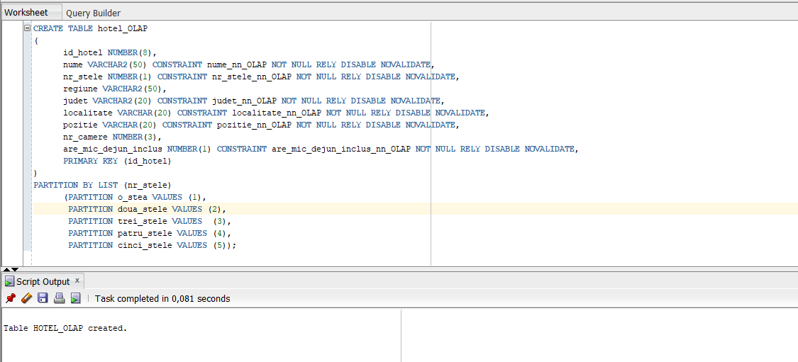

CREATE TABLE tip_client_OLAP(

id_tip_client NUMBER(8) GENERATED ALWAYS as IDENTITY(START WITH 1 INCREMENT BY 1),

varsta NUMBER(3) CONSTRAINT varsta_nn_OLAP NOT NULL RELY DISABLE NOVALIDATE,

gen VARCHAR(20),

stare_civila VARCHAR(20),

PRIMARY KEY (id_tip_client)

);

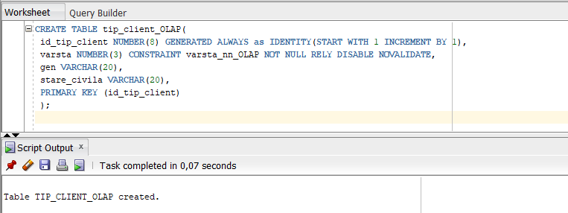

CREATE TABLE moment_efectuare_rezervare_OLAP(

id_moment_efectuare NUMBER(8,0) GENERATED ALWAYS as IDENTITY(START WITH 1 INCREMENT BY 1),

zi_din_luna NUMBER(2,0) CONSTRAINT zi_din_luna_nn_OLAP NOT NULL RELY DISABLE NOVALIDATE,

luna CHAR(3) CONSTRAINT luna_nn_OLAP NOT NULL RELY DISABLE NOVALIDATE,

an NUMBER(4,0) CONSTRAINT an_nn_OLAP NOT NULL RELY DISABLE NOVALIDATE,

zi_din_saptamana CHAR(3) CONSTRAINT zi_din_saptamana_nn_OLAP NOT NULL RELY DISABLE NOVALIDATE,

zi_din_an NUMBER(3,0) CONSTRAINT zi_din_an_nn_OLAP NOT NULL RELY DISABLE NOVALIDATE,

--ora_aprox NUMBER(2,0),

PRIMARY KEY (id_moment_efectuare)

);

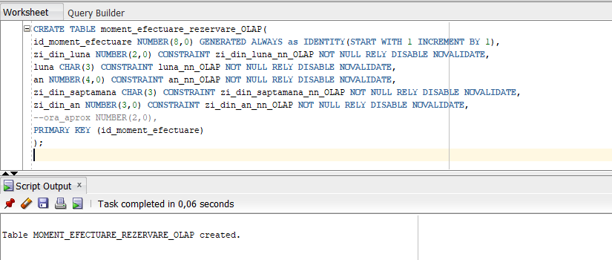

DROP TABLE rezervare_camera_OLAP;

CREATE TABLE rezervare_camera_OLAP(

id_rezervare NUMBER(8,0) CONSTRAINT id_rezervare_nn_OLAP NOT NULL RELY DISABLE NOVALIDATE,

id_hotel NUMBER(8,0) CONSTRAINT id_hotel_nn_OLAP NOT NULL RELY DISABLE NOVALIDATE,

id_perioada NUMBER(8,0) CONSTRAINT id_perioada_nn_OLAP NOT NULL RELY DISABLE NOVALIDATE,

id_moment_efectuare NUMBER(8,0) CONSTRAINT id_moment_efectuare_nn_OLAP NOT NULL RELY DISABLE NOVALIDATE,

id_tip_client NUMBER(8,0) CONSTRAINT id_tip_client_nn_OLAP NOT NULL RELY DISABLE NOVALIDATE,

id_tip_camera NUMBER(8,0) CONSTRAINT id_tip_camera_nn_OLAP NOT NULL RELY DISABLE NOVALIDATE,

pret NUMBER CONSTRAINT pret_nn_OLAP NOT NULL RELY DISABLE NOVALIDATE

);

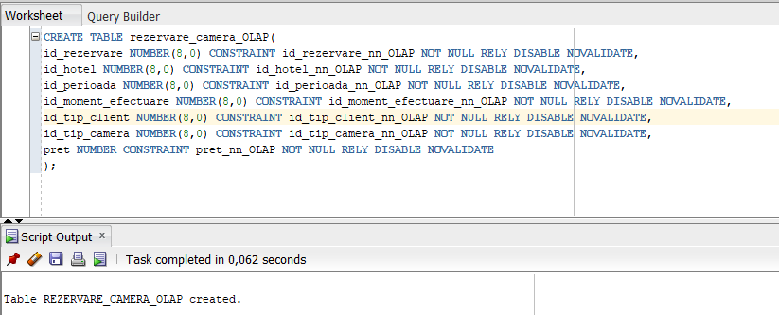

ALTER TABLE rezervare_camera_OLAP

ADD FOREIGN KEY(id_hotel) REFERENCES hotel_OLAP(id_hotel);

ALTER TABLE rezervare_camera_OLAP

ADD FOREIGN KEY(id_perioada) REFERENCES perioada_rezervare_OLAP(id_perioada);

ALTER TABLE rezervare_camera_OLAP

ADD FOREIGN KEY(id_moment_efectuare) REFERENCES moment_efectuare_rezervare_OLAP(id_moment_efectuare);

ALTER TABLE rezervare_camera_OLAP

ADD FOREIGN KEY(id_tip_camera) REFERENCES tip_camera_OLAP(id_tip_camera);

ALTER TABLE rezervare_camera_OLAP

ADD FOREIGN KEY(id_tip_client) REFERENCES tip_client_OLAP(id_tip_client);

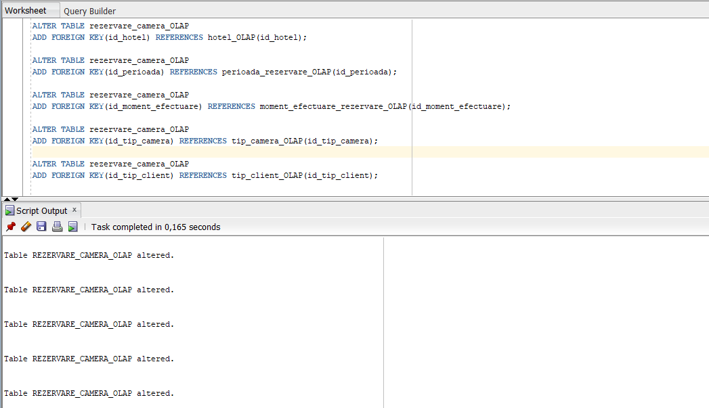

4. (0,5p) Popularea cu informații a bazei de date depozit folosind ca sursă datele

din baza de date OLTP

INSERT INTO perioada_rezervare_OLAP(zi_din_luna_inceput, luna_inceput, an_inceput, zi_din_saptamana_inceput, zi_din_an_inceput, zi_din_luna_sfarsit, luna_sfarsit, an_sfarsit, zi_din_saptamana_sfarsit, zi_din_an_sfarsit, durata_in_zile)

SELECT DISTINCT TO_NUMBER(TO_CHAR(data_inceput,'DD')), TO_CHAR(data_inceput,'MON'), TO_NUMBER(TO_CHAR(data_inceput,'YYYY')),

TO_CHAR(data_inceput,'DY'),TO_NUMBER(TO_CHAR(data_inceput,'DDD')),

TO_NUMBER(TO_CHAR(data_sfarsit,'DD')), TO_CHAR(data_sfarsit,'MON'), TO_NUMBER(TO_CHAR(data_sfarsit,'YYYY')),

TO_CHAR(data_sfarsit,'DY'),TO_NUMBER(TO_CHAR(data_sfarsit,'DDD')),

data_sfarsit - data_inceput

FROM rezervare; COMMIT;

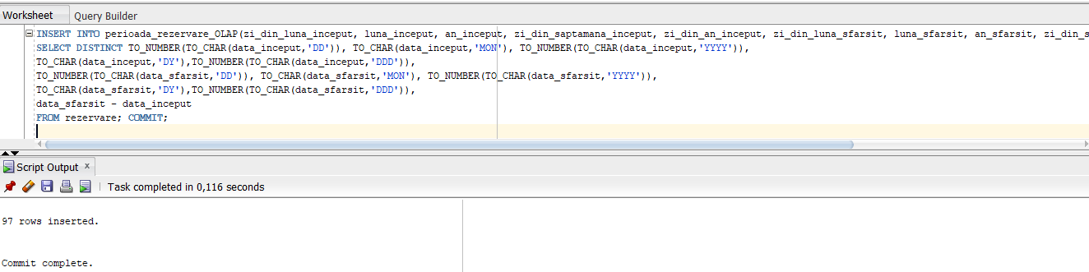

INSERT INTO moment_efectuare_rezervare_OLAP(zi_din_luna, luna, an, zi_din_saptamana, zi_din_an)

SELECT DISTINCT TO_NUMBER(TO_CHAR(data_efectuarii,'DD')), TO_CHAR(data_efectuarii,'MON'),

TO_NUMBER(TO_CHAR(data_efectuarii,'YYYY')),TO_CHAR(data_efectuarii,'DY'),TO_NUMBER(TO_CHAR(data_efectuarii,'DDD'))--,

--TO_NUMBER(TO_CHAR(data_efectuarii,'HH')) + CASE WHEN TO_NUMBER(TO_CHAR(data_efectuarii,'MI')) > 29 THEN 1 ELSE 0 END AS ora_aprox

FROM rezervare; COMMIT;

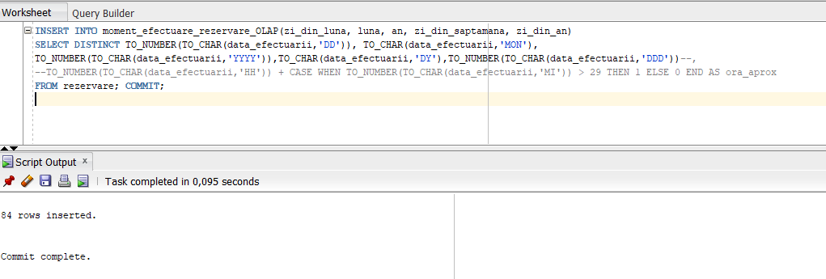

INSERT INTO hotel_OLAP(id_hotel, nume, regiune, judet, localitate, pozitie, nr_stele, are_mic_dejun_inclus)

SELECT id_hotel, nume, regiune, judet, localitate, pozitie, nr_stele, are_mic_dejun_inclus

FROM hotel JOIN zona

USING(id_zona); COMMIT;

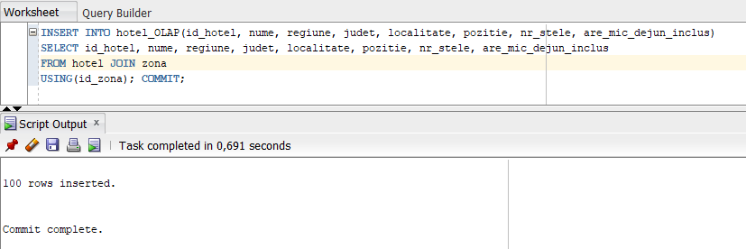

INSERT INTO tip_client_OLAP(varsta,gen,stare_civila)

SELECT DISTINCT FLOOR(MONTHS_BETWEEN(SYSDATE,data_nasterii)/12) AS varsta, gen, stare_civila

FROM utilizator; COMMIT;

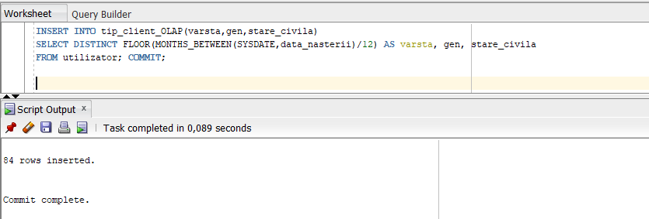

INSERT INTO tip_camera_OLAP(nr_paturi_duble, nr_paturi_simple,are_terasa,are_televizor)

SELECT DISTINCT nr_paturi_duble, nr_paturi_simple,are_terasa,are_televizor

FROM camera; COMMIT;

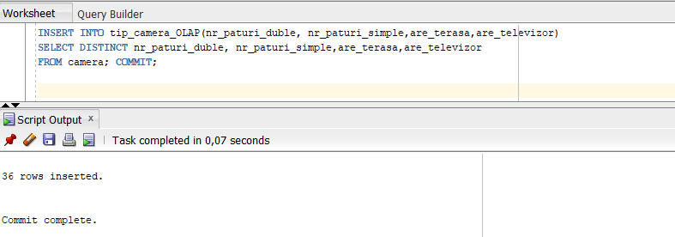

—--functie ce calculeaza varsta clientului-

CREATE OR REPLACE FUNCTION calculeaza_varsta(data_nasterii DATE)

RETURN NUMBER IS

BEGIN

RETURN FLOOR(MONTHS_BETWEEN(SYSDATE,data_nasterii)/12);

END calculeaza_varsta;

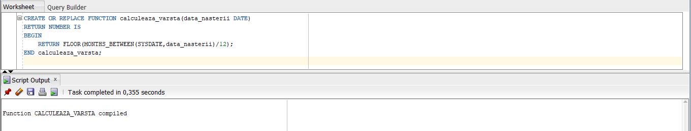

—--functie ce cauta id-ul perioadei de rezervare—

CREATE OR REPLACE FUNCTION gaseste_id_perioada_OLAP(p_zi_din_an_inceput perioada_rezervare_OLAP.zi_din_an_inceput%TYPE, p_an_inceput perioada_rezervare_OLAP.an_inceput%TYPE,

p_zi_din_an_sfarsit perioada_rezervare_OLAP.zi_din_an_sfarsit%TYPE, p_an_sfarsit perioada_rezervare_OLAP.an_sfarsit%TYPE)

RETURN perioada_rezervare_OLAP.id_perioada%TYPE IS

v_id_gasit perioada_rezervare_OLAP.id_perioada%TYPE;

BEGIN

SELECT id_perioada

INTO v_id_gasit

FROM perioada_rezervare_OLAP

WHERE zi_din_an_inceput=p_zi_din_an_inceput

AND an_inceput=p_an_inceput

AND zi_din_an_sfarsit=p_zi_din_an_sfarsit

AND an_sfarsit= p_an_sfarsit;

RETURN v_id_gasit;

END gaseste_id_perioada_OLAP;

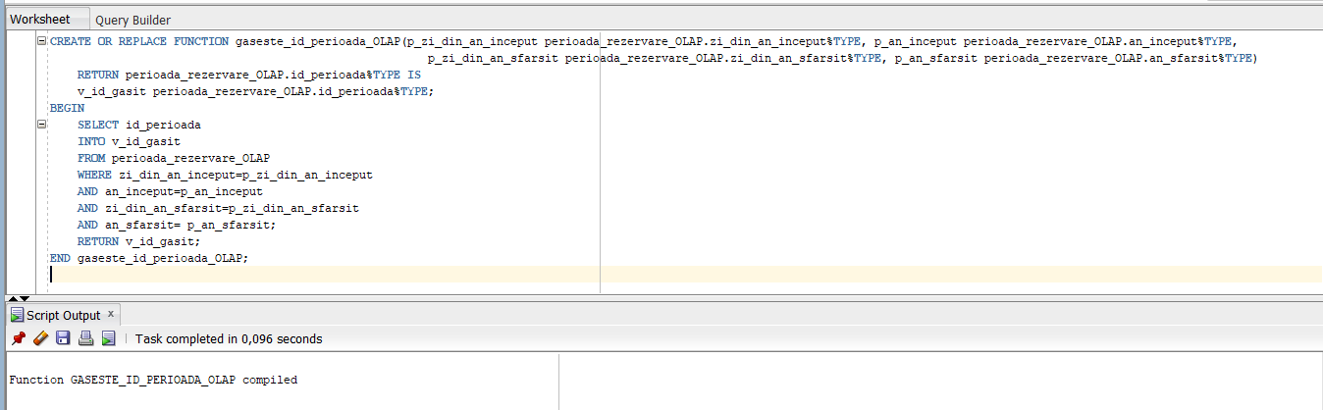

—--functie ce cauta id-ul momentului rezervarii—

CREATE OR REPLACE FUNCTION gaseste_id_moment_efectuare_OLAP(p_zi_din_an moment_efectuare_rezervare_OLAP.zi_din_an%TYPE, p_an moment_efectuare_rezervare_OLAP.an%TYPE)

RETURN moment_efectuare_rezervare_OLAP.id_moment_efectuare%TYPE IS

v_id_gasit moment_efectuare_rezervare_OLAP.id_moment_efectuare%TYPE;

BEGIN

SELECT id_moment_efectuare

INTO v_id_gasit

FROM moment_efectuare_rezervare_OLAP

WHERE an=p_an

AND zi_din_an=p_zi_din_an;

RETURN v_id_gasit;

END gaseste_id_moment_efectuare_OLAP;

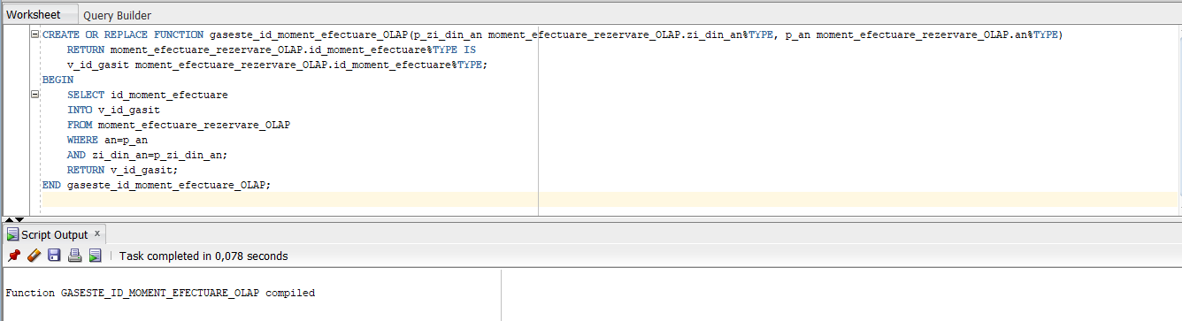

—--functie ce cauta id-ul camerei—

CREATE OR REPLACE FUNCTION gaseste_id_tip_camera_OLAP(p_nr_paturi_duble tip_camera_OLAP.nr_paturi_duble%TYPE, p_nr_paturi_simple tip_camera_OLAP.nr_paturi_duble%TYPE,

p_are_terasa tip_camera_OLAP.are_terasa%TYPE, p_are_televizor tip_camera_OLAP.are_televizor%TYPE)

RETURN tip_camera_OLAP.id_tip_camera%TYPE IS

v_id_gasit tip_camera_OLAP.id_tip_camera%TYPE;

BEGIN

SELECT id_tip_camera

INTO v_id_gasit

FROM tip_camera_OLAP

WHERE nr_paturi_duble=p_nr_paturi_duble

AND nr_paturi_simple=p_nr_paturi_simple

AND are_terasa=p_are_terasa

AND are_televizor=p_are_televizor;

RETURN v_id_gasit;

END gaseste_id_tip_camera_OLAP;

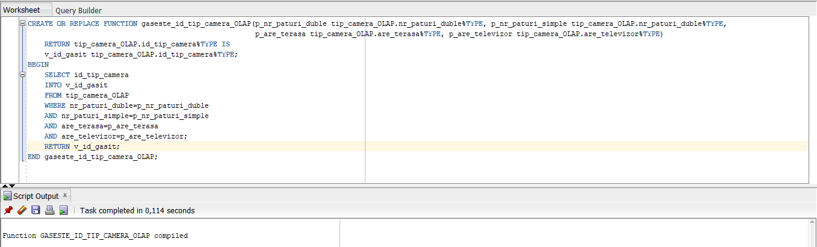

—--functie ce cauta id-ul clientului—

CREATE OR REPLACE FUNCTION gaseste_id_tip_client_OLAP (p_varsta tip_client_OLAP.varsta%TYPE, p_gen tip_client_OLAP.gen%TYPE,p_stare_civila tip_client_OLAP.stare_civila%TYPE)

RETURN tip_client_OLAP.id_tip_client%TYPE IS

v_id_gasit tip_client_OLAP.id_tip_client%TYPE;

BEGIN

SELECT id_tip_client

INTO v_id_gasit

FROM tip_client_OLAP

WHERE varsta=p_varsta

AND gen=p_gen

AND stare_civila=p_stare_civila;

RETURN v_id_gasit;

END gaseste_id_tip_client_OLAP;

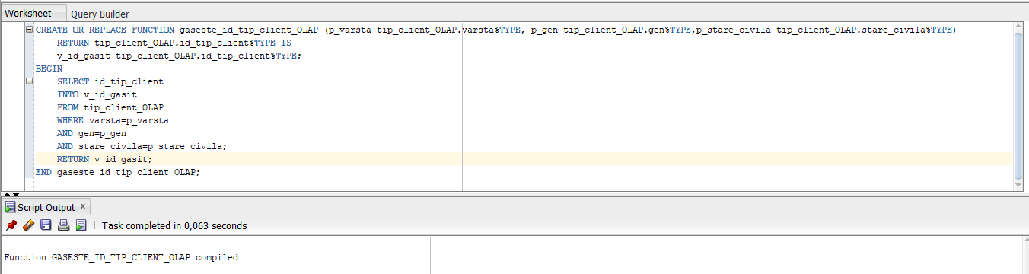

INSERT INTO rezervare_camera_OLAP(id_rezervare,id_hotel,id_perioada,id_moment_efectuare,id_tip_camera,id_tip_client,pret)

SELECT DISTINCT id_rezervare,id_hotel,

gaseste_id_perioada_OLAP(TO_NUMBER(TO_CHAR(data_inceput,'DDD')),TO_NUMBER(TO_CHAR(data_inceput,'YYYY')),

TO_NUMBER(TO_CHAR(data_sfarsit,'DDD')),TO_NUMBER(TO_CHAR(data_sfarsit,'YYYY'))) AS id_perioada,

gaseste_id_moment_efectuare_OLAP(TO_NUMBER(TO_CHAR(data_efectuarii,'DDD')),TO_NUMBER(TO_CHAR(data_efectuarii,'YYYY'))) AS id_moment_efectuare,

gaseste_id_tip_camera_OLAP(camera.nr_paturi_duble,camera.nr_paturi_simple,camera.are_terasa,camera.are_televizor) AS id_tip_camera,

gaseste_id_tip_client_OLAP(calculeaza_varsta(utilizator.data_nasterii),utilizator.gen,utilizator.stare_civila) AS id_tip_client,

camera.pret_per_noapte * (rezervare.data_sfarsit - rezervare.data_inceput) AS pret

FROM utilizator JOIN rezervare

ON utilizator.id_utilizator=rezervare.id_client

JOIN rezervare_camera

USING(id_rezervare)

JOIN camera

USING(id_camera)

JOIN hotel

USING(id_hotel); COMMIT;

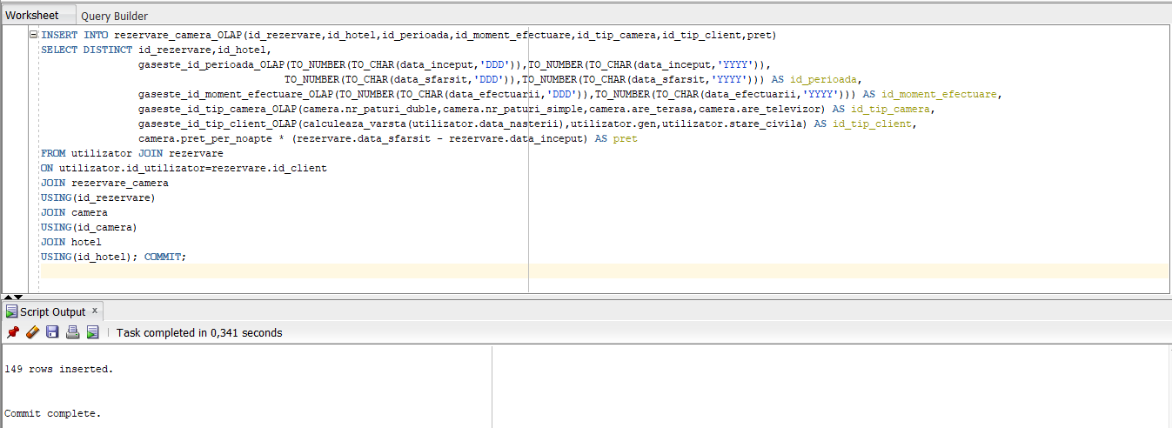

5. (0,5p) Definirea constrângerilor

Constrângerile au fost definite încă de la momentul creării tabelelor bazei de date depozit.

Exemple:

luna_inceput CHAR(3) CONSTRAINT luna_inceput_nn_OLAP NOT NULL RELY DISABLE NOVALIDATE,

nr_paturi_duble NUMBER(1) CONSTRAINT nr_paturi_duble_nn_OLAP NOT NULL RELY DISABLE NOVALIDATE,

nr_stele NUMBER(1) CONSTRAINT nr_stele_nn_OLAP NOT NULL RELY DISABLE NOVALIDATE,

varsta NUMBER(3) CONSTRAINT varsta_nn_OLAP NOT NULL RELY DISABLE NOVALIDATE,

zi_din_an NUMBER(3,0) CONSTRAINT zi_din_an_nn_OLAP NOT NULL RELY DISABLE NOVALIDATE,

6. (1p) Definirea indecșilor și a cererilor SQL însoțite de planul de execuție al

acestora (din care să reiasă ca optimizorul utilizează eficient indecșii definiți)

CREATE INDEX id_rezervare_index_OLAP

ON rezervare_camera_OLAP(id_rezervare);

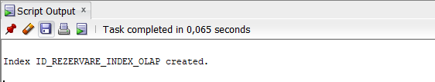

CREATE BITMAP INDEX luna_an_efectuare_bjindex_OLAP

ON rezervare_camera_OLAP(moment_efectuare_OLAP.luna,moment_efectuare_OLAP.an)

FROM moment_efectuare_OLAP,rezervare_camera_OLAP

WHERE rezervare_camera_OLAP.id_moment_efectuare= moment_efectuare_OLAP.id_moment_efectuare;

CREATE BITMAP INDEX localitate_pozitie_bjindex_OLAP

ON rezervare_camera_OLAP(hotel.localitate,hotel.pozitie)

FROM hotel_OLAP, rezervare_camera_OLAP

WHERE rezervare_camera_OLAP.id_hotel = hotel_OLAP.id_hotel;

CREATE BITMAP INDEX nr_paturi_duble_nr_paturi_simple_bjindex_OLAP

ON rezervare_camera_OLAP(tip_camera_OLAP.nr_paturi_duble,tip_camera_OLAP.nr_paturi_simple)

FROM tip_camera_OLAP, rezervare_camera_OLAP

WHERE tip_camera_OLAP.id_tip_camera= rezervare_camera_OLAP.id_tip_camera;

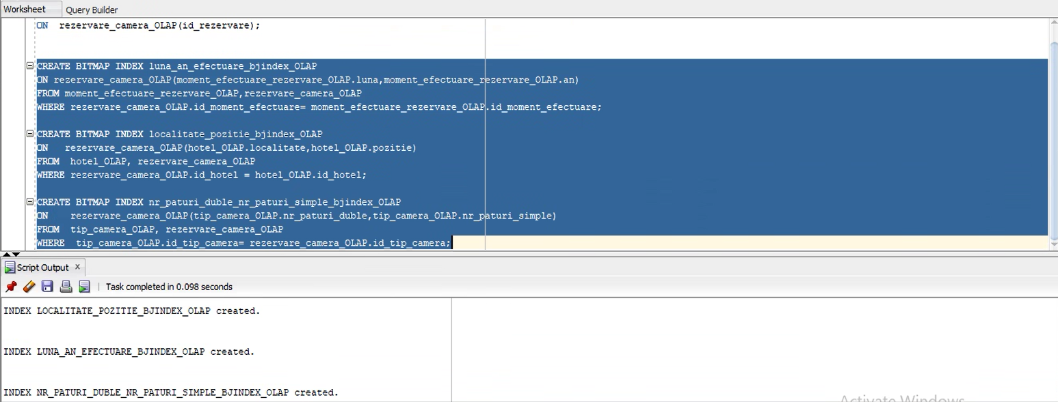

7. (1p) Definirea obiectelor de tip dimensiune, validarea acestora (din care să

reiasă că datele respectă constrângerile impuse prin aceste tipuri de obiecte)

CREATE DIMENSION perioada_rezervare_dim_OLAP

LEVEL zi_din_an_inceput IS perioada_rezervare_OLAP.zi_din_an_inceput

LEVEL zi_din_an_sfarsit IS perioada_rezervare_OLAP.zi_din_an_sfarsit

ATTRIBUTE zi_din_an_inceput DETERMINES ( perioada_rezervare_OLAP.zi_din_luna_inceput, perioada_rezervare_OLAP.luna_inceput, perioada_rezervare_OLAP.zi_din_saptamana_inceput)

ATTRIBUTE zi_din_an_sfarsit DETERMINES ( perioada_rezervare_OLAP.zi_din_luna_sfarsit, perioada_rezervare_OLAP.luna_sfarsit, perioada_rezervare_OLAP.zi_din_saptamana_sfarsit);

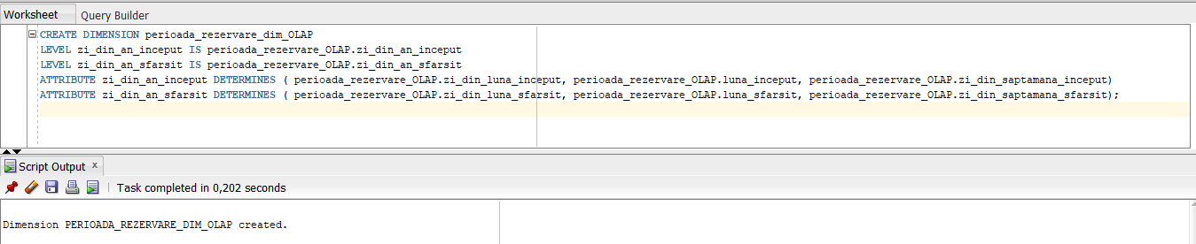

CREATE DIMENSION moment_efectuare_rezervare_dim_OLAP

LEVEL zi_din_an IS moment_efectuare_rezervare_OLAP.zi_din_an

ATTRIBUTE zi_din_an DETERMINES ( moment_efectuare_rezervare_OLAP.zi_din_luna, moment_efectuare_rezervare_OLAP.luna, moment_efectuare_rezervare_OLAP.zi_din_saptamana);

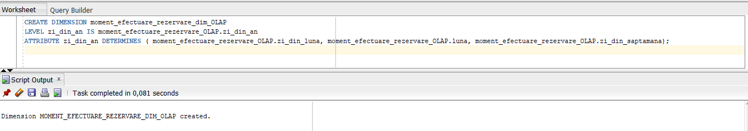

--Ierarhia de mai jos este problematica deoarece exista posibilitatea ca numele a doua localitati din judete diferite sa coincida

CREATE DIMENSION hotel_dim_OLAP

LEVEL regiune IS hotel_OLAP.regiune

LEVEL judet IS hotel_OLAP.judet

LEVEL localitate IS hotel_OLAP.localitate

HIERARCHY judet_localitate (

localitate CHILD OF

judet CHILD OF

regiune

);

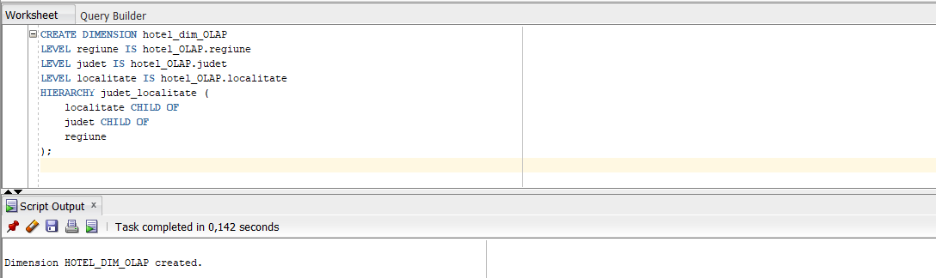

CREATE DIMENSION id_rezervare_dim_OLAP

LEVEL id_rezervare IS rezervare_camera_OLAP.id_rezervare

ATTRIBUTE id_rezervare DETERMINES (rezervare_camera_OLAP.id_perioada_rezervare, rezervare_camera_OLAP.id_moment_efectuare_rezervare, rezervare_camera_OLAP.id_hotel, rezervare_camera_OLAP.id_tip_client);

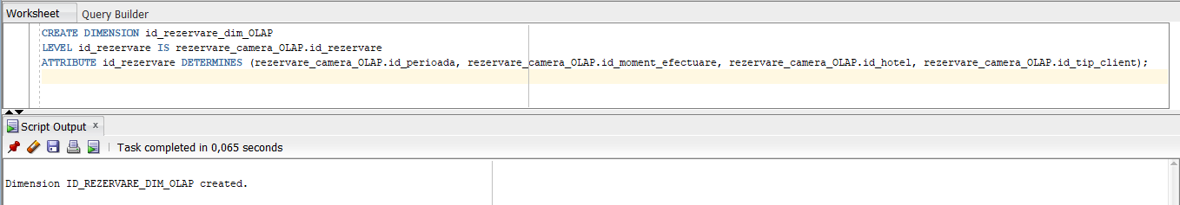

8. (1p) Definirea partițiilor; definirea cererilor SQL însoțite de planul de execuție al acestora din care să reiasă ca optimizorul utilizează eficient partițiile.

–pentru hotel

PARTITION BY LIST (nr_stele)

(PARTITION o_stea VALUES (1),

PARTITION doua_stele VALUES (2),

PARTITION trei_stele VALUES (3),

PARTITION patru_stele VALUES (4),

PARTITION cinci_stele VALUES (5));

—pentru rezervare_camera

PARTITION BY RANGE(pret)

(PARTITION pret_sub_1000 VALUES LESS THAN (1000),

PARTITION pret_sub_2500 VALUES LESS THAN (2500),

PARTITION pret_sub_5000 VALUES LESS THAN (5000),

PARTITION pret_peste_5000 VALUES LESS THAN (MAXVALUE));

9. (2p) Optimizarea cererii SQL propusă în etapa de analiză C8 / L7

a. (1p) planul de execuție ales de optimizorul bazat pe cost (explicație etape parcurse)

Se consideră cererea SQL ce afișează numele hotelurilor ce au avut suma rezervărilor cuprinsă între

SELECT nume, SUM(pret) AS suma

FROM hotel_OLAP, rezervare_camera_OLAP

where rezervare_camera_olap.id_hotel = hotel_olap.id_hotel

GROUP BY nume

HAVING SUM(pret) between 1000 and 2000;

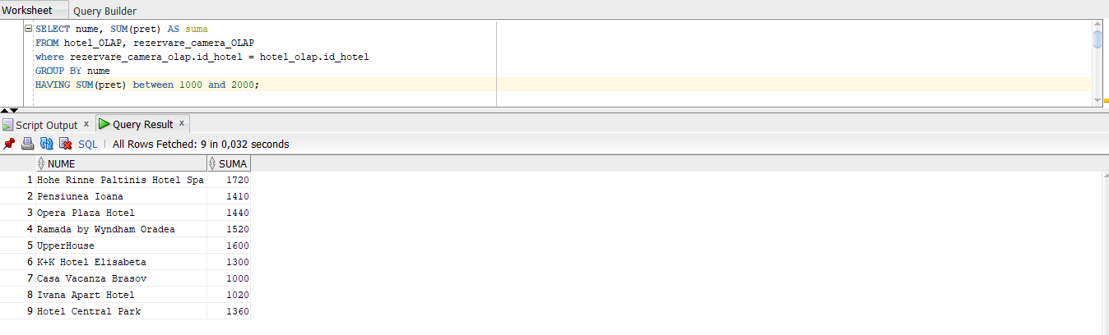

b. (1p) sugestii de optimizare a cererii, specificând planul de execuție obținut

Se poate crea o vizualizare materializată astfel:

CREATE MATERIALIZED VIEW pret_rezervare_camera_mw

BUILD IMMEDIATE

REFRESH FORCE

ENABLE QUERY REWRITE

AS

SELECT nume,

SUM(pret) AS suma

FROM hotel_OLAP, rezervare_camera_OLAP

WHERE rezervare_camera_olap.id_hotel = hotel_olap.id_hotel

GROUP BY nume

HAVING SUM(pret) BETWEEN 10 AND 4000;

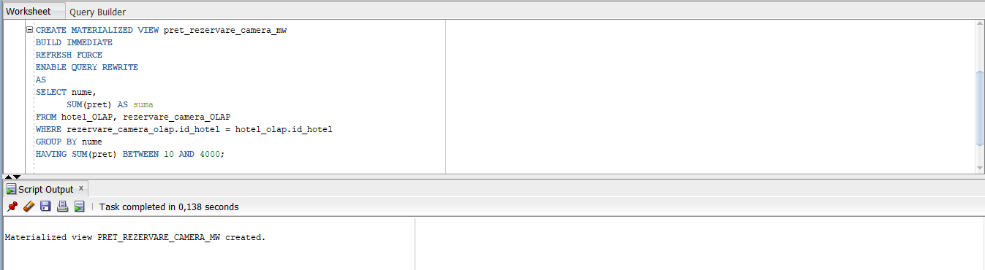

Iar cererea se poate rescrie astfel:

SELECT nume, suma

FROM pret_rezervare_camera_mw

WHERE suma>100 AND suma<2000;

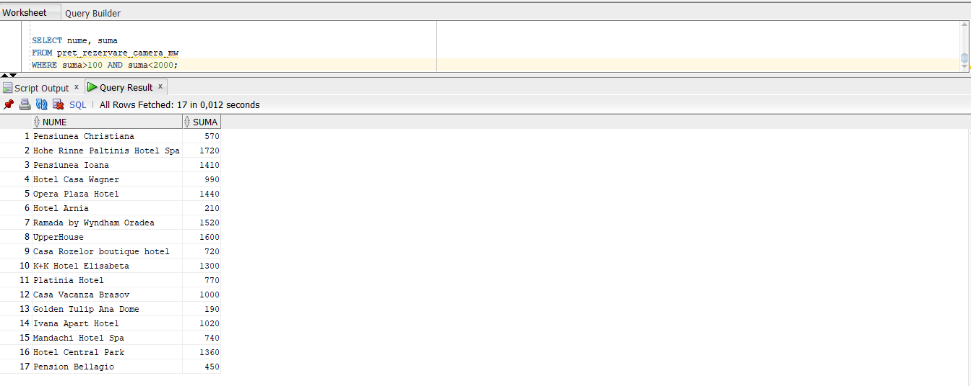

10. (2p) Crearea rapoartelor cu complexitate diferită (la acest nivel vor fi

scripturi SQL, fără reprezentare grafică)

SELECT moment_efectuare_rezervare_olap.luna lunaefectuare, COUNT(tip_camera_olap.id_tip_camera) numar, GROUPING_ID (luna) grouping_id

FROM rezervare_camera_olap, moment_efectuare_rezervare_olap, tip_camera_olap

WHERE rezervare_camera_olap.id_tip_camera= tip_camera_olap.id_tip_camera

AND rezervare_camera_olap.id_moment_efectuare= moment_efectuare_rezervare_olap.id_moment_efectuare

GROUP BY ROLLUP ( moment_efectuare_rezervare_olap.luna );

